Step 1) Full Gid form for inner current loop use below equation:
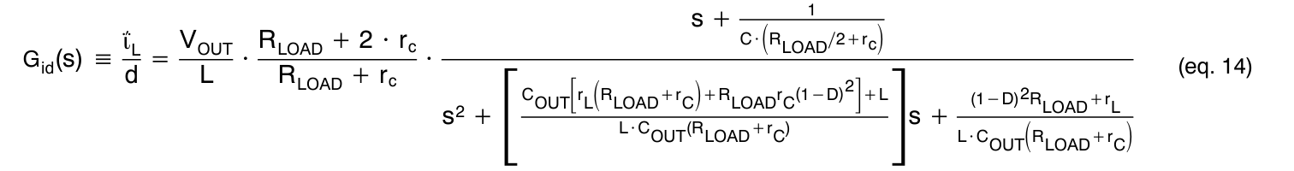
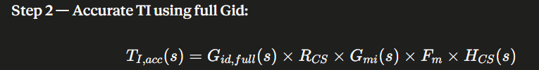
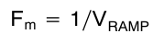
Hcs(s) = Filter across current sense resistor
Gmi(s) = Current compensator = gmi * Ziea = Type 2 OTA
Rcs =Current sense Resistor
Means equation becomes:
Current Loop Gain Ti(s)
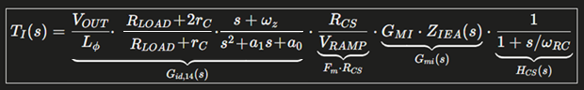
Where:
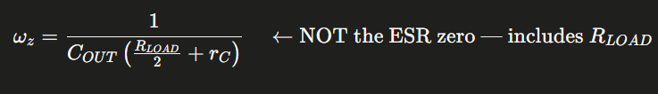
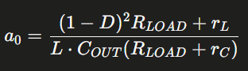
Now once we have inner current loop, next step is to find outer voltage loop.
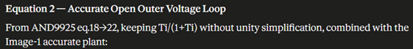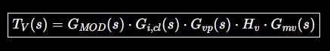
Voltage Loop Gain Tv(s)
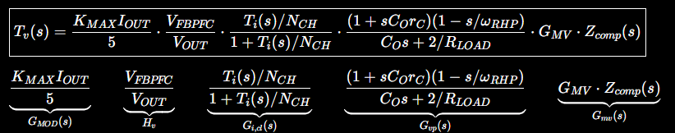
Where,
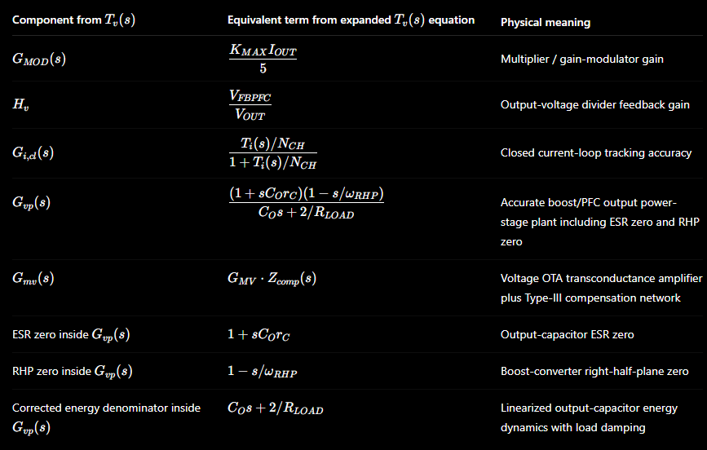

Now do step by step calculation using improved equations in attachment for
- Current Loop Gain Ti(s)
- Voltage Loop Gain Tv(s)
Show gain margin and phase margin of each voltage and current loop along with step by step calculation‌ for
- Input voltage of 90VAC/110VAC/120VAC/132VAC for 1700W output and 180VAC/210VAC/220VAC/264VAC for 3600W output.
- Generate bode plot and summary table showing phase margin, gain margin and cross over at each voltage.
- Take Rcs = 15 mOHM, Vout = 393V, Nch = 2, Vramp = 5V, Co = 2200 uF, L = 235 uH per phase
- G_{MV} = 100 u , G_{MI} = 88 u , K_{max} = 1.4, R_{L} = 10 mOHM, r_{C} = 10 mOHM, V_{FBPFC} = 2.5, V_{RAMP} = 5V
- Voltage feedback resistors: Vfb_top = 3.63 MOHM, Vfb_bottom = 23.2KOHM
- Inner current loop will be type 2 OTA with high frequency pole for current sensing at 169 KHz. (R =2KOHM and C = 470 pF).
- Current loop crossover frequency will be 8 KHz.
- Current loop will have Z1 at 1 KHZ and P1 at 26KHZ.
- Voltage loop cross over is at 17 Hz.
- Voltage loop compensator will be type 3 OTA.
- Voltage loop will have Z1 at 3Hz, Z2 at 12 Hz, P1 at 17 Hz and P2 at 50 Hz.
Generate bode plot showing Gain and phase margin for
- Open Inner Current Loop for all 8 voltages
- Closed inner current loop for all 8 voltages
- Open Voltage loop for low line voltages
- Open Voltage loop for High line voltages
- Closed voltage loop for low line voltages
- Closed voltage loop for High line voltages
Generate summary table having below columns showing
- VAC
- Pout
- Duty
- Fo (Hz)
- Q
- Current loop Fcrossover (KHz)
- Open Current loop Gain
- Open Current Loop Phase
- Voltage loop Fcrossover (KHz)
- Open Voltage loop Gain
- Open Voltage Loop Phase
- Closed Voltage loop Gain
- Closed Voltage Loop Phase
- 120 Hz Open loop Gain and Phase
- 120 Hz Closed loop Gain and Phase
Generate step load response and a summary table for all 8 voltages showing voltage dip or overshoot and recovery time for
- 0% to 100% step load
- 0% to 50% step load
- 50% to 100% step load
- 100% to 0% step load
- 50% to 0% step load
- 100% to 50% step load
We can not change power components which means inductor, capacitor etc. but only can modify voltage and current loop compensators' pole zero placement. Calculate and suggest how we can improve pole zero placement of both loops to improve transient response, better 120 Hz rejection and THD improvement.
Calculate current compensator components (R and C) values and Voltage compensator components (R & C) values. Suggest standard components.
Calculate other IC parameters

To calculate inner current loop components, Consider Ti(s) in below equation without compensator. Means:
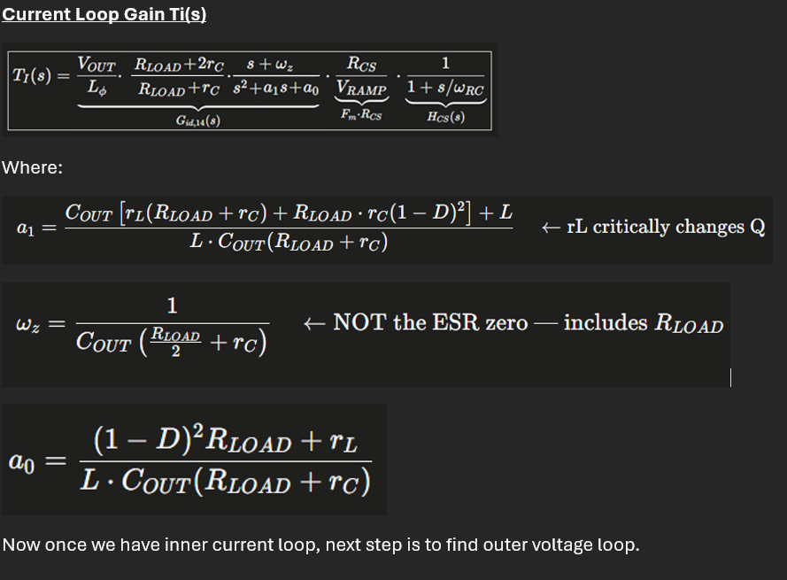
$$R_{LOAD}=\frac{V_{OUT}^{2}}{P_{OUT}}$$
in the front gain factor and $ω_{z}$.

1. Current loop without compensator
$$T_{i}(s)=\frac{V_{OUT}}{L_{ϕ}}⋅\frac{R_{LOAD}+2r_{C}}{R_{LOAD}+r_{C}}⋅\frac{s+ω_{z}}{s^{2}+a_{1}s+a_{0}}⋅\frac{R_{CS}}{V_{RAMP}}⋅\frac{1}{1+s/ω_{RC}}$$
This is without:
$$GMI⋅Z_{IEA}(s)$$

2. Given values
$$V_{OUT}=390V \\ L_{ϕ}=235μH \\ C_{O}=2200μF \\ r_{L}=10mΩ \\ r_{C}=10mΩ \\ R_{CS}=15mΩ \\ V_{RAMP}=5V \\ R_{F}=2kΩ \\ C_{F}=470pF \\ f_{ci}=8kHz$$

3. Example: 90 Vac, 1700 W
Load resistance
$$R_{LOAD}=\frac{V_{OUT}^{2}}{P_{OUT}} \\ R_{LOAD}=\frac{{390}^{2}}{1700} \\ \boxed{R_{LOAD}=89.4706Ω}$$
Duty cycle
$$V_{IN,pk}=\sqrt{2}⋅90=127.279V \\ D=1-\frac{V_{IN,pk}}{V_{OUT}} \\ D=1-\frac{127.279}{390} \\ \boxed{D=0.67364}$$

4. Correct front factor
$$K_{front}=\frac{V_{OUT}}{L_{ϕ}}⋅\frac{R_{LOAD}+2r_{C}}{R_{LOAD}+r_{C}} \\ \frac{R_{LOAD}+2r_{C}}{R_{LOAD}+r_{C}}=\frac{89.4706+2(0.01)}{89.4706+0.01} \\ \boxed{=1.00011} \\ \frac{V_{OUT}}{L_{ϕ}}=\frac{390}{235μH} \\ =1.6596×{10}^{6} \\ \boxed{K_{front}=1.6598×{10}^{6}}$$

5. Calculate $ω_{z}$
$$ω_{z}=\frac{1}{C_{O}(R_{LOAD}/2+r_{C})} \\ ω_{z}=\frac{1}{2200μF(89.4706/2+0.01)} \\ \boxed{ω_{z}=10.1585 rad/s} \\ f_{z}=\frac{ω_{z}}{2π} \\ \boxed{f_{z}=1.617Hz}$$

6. Calculate $a_{1}$
$$a_{1}=\frac{C_{O}\left[r_{L}(R_{LOAD}+r_{C})+R_{LOAD}r_{C}(1-D)^{2}\right]+L}{LC_{O}(R_{LOAD}+r_{C})}$$
Substituting:
$$a_{1}=\frac{2200μF[0.01(89.4706+0.01)+89.4706(0.01)(0.32636)^{2}]+235μH}{235μH⋅2200μF(89.4706+0.01)} \\ \boxed{a_{1}=52.1648}$$
7. Calculate $a_{0}$
$$a_{0}=\frac{\left(1-D)^{2}R_{LOAD}+r_{L}\right.}{LC_{O}(R_{LOAD}+r_{C})} \\ a_{0}=\frac{(0.32636)^{2}(89.4706)+0.01}{235μH⋅2200μF(89.4706+0.01)} \\ \boxed{a_{0}=2.06206×{10}^{5}}$$

8. Evaluate at crossover
$$f_{ci}=8kHz \\ ω=2πf=2π(8000) \\ \boxed{ω=50265.48 rad/s} \\ s=j50265.48 \\ G_{id,14}(s)=K_{front}⋅\frac{s+ω_{z}}{s^{2}+a_{1}s+a_{0}}$$
At $8kHz$:
$$\boxed{∣G_{id,14}(j2π8k)∣=33.0226} \\ \boxed{∠G_{id,14}=-{89.952}^{∘}}$$
9. Add $R_{CS}/V_{RAMP}$
$$\frac{R_{CS}}{V_{RAMP}}=\frac{0.015}{5} \\ \boxed{=0.003} \\ 33.0226⋅0.003=0.0990677$$

10. Add current-sense filter
$$f_{RC}=\frac{1}{2πR_{F}C_{F}} \\ f_{RC}=\frac{1}{2π(2000)(470pF)} \\ \boxed{f_{RC}=169.314kHz} \\ H_{CS}(s)=\frac{1}{1+s/ω_{RC}}$$
At 8 kHz:
$$∣H_{CS}∣=\frac{1}{\sqrt{1+(8000/169314)^{2}}} \\ \boxed{∣H_{CS}∣=0.99889} \\ ∠H_{CS}=-{tan⁡}^{-1}\left(\frac{8000}{169314}\right) \\ \boxed{∠H_{CS}=-{2.705}^{∘}}$$

11. Final $T_{i}(s)$without compensator
$$∣T_{i}∣=∣G_{id,14}∣⋅\frac{R_{CS}}{V_{RAMP}}⋅∣H_{CS}∣ \\ ∣T_{i}∣=33.0226⋅0.003⋅0.99889 \\ \boxed{∣T_{i}(j2π8k)∣=0.09896}$$
Gain in dB:
$$20{log⁡}_{10}(0.09896) \\ \boxed{-20.09dB}$$
Phase:
$$∠T_{i}=∠G_{id,14}+∠H_{CS} \\ ∠T_{i}=-{89.952}^{∘}-{2.705}^{∘} \\ \boxed{∠T_{i}=-{92.657}^{∘}}$$

Final answer at 90 Vac / 1700 W
$$\boxed{∣T_{i}∣_{\text{without compensator}}=0.09896} \\ \boxed{T_{i}=-20.09dB} \\ \boxed{∠T_{i}=-{92.66}^{∘}}$$

Across all operating points
| Vin | Pout | $R_{LOAD}$| Duty $D$| $∣T_{i}∣$at 8 kHz | Gain | Phase |
|---:|---:|---:|---:|---:|---:|---:|
| 90 Vac | 1700 W | 89.47 Ω | 0.6736 | 0.09896 | -20.09 dB | -92.66° |
| 110 Vac | 1700 W | 89.47 Ω | 0.6011 | 0.09896 | -20.09 dB | -92.65° |
| 120 Vac | 1700 W | 89.47 Ω | 0.5649 | 0.09896 | -20.09 dB | -92.65° |
| 132 Vac | 1700 W | 89.47 Ω | 0.5213 | 0.09897 | -20.09 dB | -92.65° |
| 180 Vac | 3600 W | 42.25 Ω | 0.3473 | 0.09899 | -20.09 dB | -92.65° |
| 210 Vac | 3600 W | 42.25 Ω | 0.2385 | 0.09901 | -20.09 dB | -92.64° |
| 220 Vac | 3600 W | 42.25 Ω | 0.2022 | 0.09901 | -20.09 dB | -92.64° |
| 264 Vac | 3600 W | 42.25 Ω | 0.0427 | 0.09903 | -20.08 dB | -92.62° |
So the correct uncompensated current-loop gain is:
$$\boxed{∣T_{i}∣≈0.099}$$
not $0.1487$, because the front gain must use $R_{LOAD}$, not $r_{L}$.
Using:
$$∣T_{i}∣_{\text{without compensator}}=0.09896 \\ GMI=88μS \\ f_{ci}=8kHz \\ f_{z}=1kHz \\ f_{p}=26kHz$$
1. Current compensator form
$$G_{mi}(s)=GMI⋅Z_{IEA}(s) \\ Z_{IEA}(s)=R_{IC}⋅\frac{1+ω_{z}/s}{1+s/ω_{p}}$$
At crossover:
$$∣T_{i}(jω_{ci})∣⋅GMI⋅∣Z_{IEA}(jω_{ci})∣=1$$

2. Compensator shape magnitude at 8 kHz
$$∣\frac{1+ω_{z}/s}{1+s/ω_{p}}∣=\frac{\sqrt{1+(f_{z}/f_{ci})^{2}}}{\sqrt{1+(f_{ci}/f_{p})^{2}}} \\ =\frac{\sqrt{1+(1000/8000)^{2}}}{\sqrt{1+(8000/26000)^{2}}} \\ \boxed{=0.9632}$$

3. Calculate $R_{IC}$
$$R_{IC}=\frac{1}{∣T_{i}∣⋅GMI⋅0.9632} \\ R_{IC}=\frac{1}{0.09896⋅88μS⋅0.9632} \\ \boxed{R_{IC}=119.2kΩ}$$
Recommended standard:
$$\boxed{R_{IC}=120kΩ}$$

4. Calculate $C_{IC1}$
$$f_{z}=\frac{1}{2πR_{IC}C_{IC1}} \\ C_{IC1}=\frac{1}{2πR_{IC}f_{z}} \\ C_{IC1}=\frac{1}{2π⋅119.2k⋅1k} \\ \boxed{C_{IC1}=1.335nF}$$
Recommended standard:
$$\boxed{C_{IC1}=1.3nF}$$

5. Calculate $C_{IC2}$
$$f_{p}=\frac{1}{2πR_{IC}C_{IC2}} \\ C_{IC2}=\frac{1}{2πR_{IC}f_{p}} \\ C_{IC2}=\frac{1}{2π⋅119.2k⋅26k} \\ \boxed{C_{IC2}=51.35pF}$$
Recommended standard:
$$\boxed{C_{IC2}=51pF}$$
or:
$$\boxed{C_{IC2}=56pF}$$

Final current compensator values
Component | Calculated | Recommended standard
$$R_{IC}$$ | 119.2 kΩ | 120 kΩ
$$C_{IC1}$$ | 1.335 nF | 1.3 nF
$$C_{IC2}$$ | 51.35 pF | 51 pF / 56 pF
$$\boxed{R_{IC}=120kΩ,C_{IC1}=1.3nF,C_{IC2}=51pF}$$

- Voltage loop compensator calculation:
Consider the equation below without compensator:
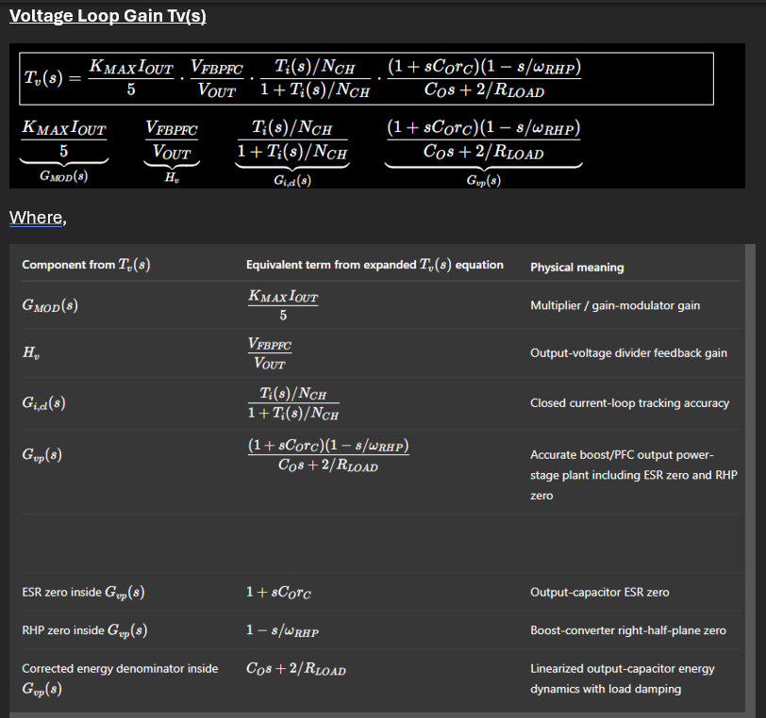
Below is the voltage-loop gain without the voltage compensator:
$$T_{v}(s)=\frac{K_{MAX}I_{OUT}}{5}⋅\frac{V_{FBPFC}}{V_{OUT}}⋅\frac{T_{i}(s)/N_{CH}}{1+T_{i}(s)/N_{CH}}⋅\frac{\left(1+sC_{O}r_{C})(1-s/ω_{RHP}\right)}{C_{O}s+2/R_{LOAD}}$$
This means I am not including:
$$G_{MV}⋅Z_{comp}(s)$$Method B means:
$$H_{v}=\frac{V_{FBPFC}}{V_{OUT}}$$
is removed from $T_{v}(s)$and becomes part of the OTA Type-III compensator transfer function from $V_{O}$to $V_{EA}$, exactly as SLVA662 page 11–12 shows for OTA Type-III. In SLVA662, the OTA Type-III transfer function includes $R_{1}$, $R_{4}$, $g_{m}$, and the compensation network together.
1. Voltage loop without feedback divider and without compensator
Use:
$$T_{v,base}(s)=\frac{K_{MAX}I_{OUT}}{5}⋅\frac{T_{i}(s)/N_{CH}}{1+T_{i}(s)/N_{CH}}⋅\frac{\left(1+sC_{O}r_{C})(1-s/ω_{RHP}\right)}{C_{O}s+2/R_{LOAD}}$$
No:
$$\frac{V_{FBPFC}}{V_{OUT}}$$
and no:
$$G_{MV}Z_{comp}(s)$$

1. Given values
$$K_{MAX}=1.49 \\ V_{OUT}=390V \\ V_{FBPFC}=2.5V \\ C_{O}=2200μF \\ r_{C}=10mΩ \\ N_{CH}=2 \\ f_{cv}=17Hz \\ s=j2π17=j106.814$$
For the current-loop term, I used the corrected current compensator:
$$R_{IC}=119.2kΩ \\ C_{IC1}=1.335nF \\ C_{IC2}=51.35pF$$

Example calculation: 180 Vac, 3600 W
2. Output current
$$I_{OUT}=\frac{P_{OUT}}{V_{OUT}}$$
$$I_{OUT}=\frac{3600}{390}=9.2308A$$

3. Multiplier gain term
$$G_{MOD}=\frac{K_{MAX}I_{OUT}}{5} \\ G_{MOD}=\frac{1.4⋅9.2308}{5} \\ \boxed{G_{MOD}=2.5846}$$

4. Current-loop closed-loop term
$$G_{i,cl}(s)=\frac{T_{i}(s)/N_{CH}}{1+T_{i}(s)/N_{CH}}$$
At 17 Hz, using the corrected current loop:
$$T_{i}(j2π17)=1619.85-j174.23 \\ ∣T_{i}∣=1629.19 \\ ∠T_{i}=-{6.14}^{∘}$$
Now:
$$G_{i,cl}(j2π17)=\frac{T_{i}/2}{1+T_{i}/2} \\ G_{i,cl}=0.998781-j0.000131 \\ \boxed{∣G_{i,cl}∣=0.998781} \\ \boxed{∠G_{i,cl}=-{0.0075}^{∘}}$$
So at 17 Hz the current loop is almost unity, but it is still included.

6. Accurate voltage plant
$$G_{vp}(s)=\frac{\left(1+sC_{O}r_{C})(1-s/ω_{RHP}\right)}{C_{O}s+2/R_{LOAD}}$$
Load resistance:
$$R_{LOAD}=\frac{{390}^{2}}{3600} \\ \boxed{R_{LOAD}=42.25Ω}$$
Duty complement:
$$D^{'}=\frac{\sqrt{2}⋅180}{390} \\ \boxed{D^{'}=0.6526}$$
RHP zero:
$$ω_{RHP}=\frac{R_{LOAD}(D^{'})^{2}}{L_{eq}} \\ L_{eq}=\frac{235μH}{2}=117.5μH \\ ω_{RHP}=153138 rad/s \\ \boxed{f_{RHP}=24.38 kHz}$$
At 17 Hz:
$$G_{vp}(j2π17)=0.40553-j4.21692 \\ \boxed{∣G_{vp}∣=4.23637} \\ \boxed{∠G_{vp}=-{84.51}^{∘}}$$

7. Final voltage-loop gain without compensator
$$T_{v}=G_{MOD}⋅H_{v}⋅G_{i,cl}⋅G_{vp} \\ T_{v}=1.22051⋅0.0064103⋅(0.998781-j0.000131)⋅(0.40553-j4.21692) \\ T_{v}=0.003165-j0.032953 \\ \boxed{∣T_{v}(j2π17)∣=0.03310} \\ 20{log⁡}_{10}(0.03310) \\ \boxed{T_{v}=-29.60dB} \\ \boxed{∠T_{v}=-{84.51}^{∘}}$$

Results across all operating points
| Vin | Pout | $R_{LOAD}$| $f_{RHP}$| $∣T_{v}∣$at 17 Hz | Gain | Phase |
|---:|---:|---:|---:|---:|---:|---:|
| 90 Vac | 1700 W | 89.47 Ω | 12.91 kHz | 0.03310 | -29.60 dB | -84.51° |
| 110 Vac | 1700 W | 89.47 Ω | 19.28 kHz | 0.03308 | -29.61 dB | -84.49° |
| 120 Vac | 1700 W | 89.47 Ω | 22.95 kHz | 0.03307 | -29.61 dB | -84.49° |
| 132 Vac | 1700 W | 89.47 Ω | 27.77 kHz | 0.03305 | -29.62 dB | -84.48° |
| 180 Vac | 3600 W | 42.25 Ω | 24.38 kHz | 0.06878 | -23.25 dB | -78.57° |
| 210 Vac | 3600 W | 42.25 Ω | 33.19 kHz | 0.06865 | -23.27 dB | -78.58° |
| 220 Vac | 3600 W | 42.25 Ω | 36.42 kHz | 0.06861 | -23.27 dB | -78.58° |
| 264 Vac | 3600 W | 42.25 Ω | 52.45 kHz | 0.06838 | -23.30 dB | -78.61° |

Final answer
At the selected voltage-loop crossover:
$$f_{cv}=17Hz$$
the voltage-loop gain without the voltage compensator is:
High Line 3600 W region
$$\boxed{∣T_{v,base}∣=10.731} \\ \boxed{T_{v,base}=20.61dB} \\ \boxed{∠T_{v,base}=-{78.57}^{∘}}$$
So the required OTA Type-III compensator magnitude is:
$$∣H_{OTA}(17Hz)∣=\frac{1}{10.731} \\ \boxed{∣H_{OTA}(17Hz)∣=0.09319} \\ \boxed{H_{OTA}(17Hz)=-20.61dB} \\ \boxed{∠T_{v}≈-{78.57}^{∘}}$$
So the voltage compensator $G_{MV}Z_{comp}(s)$must provide approximately:
$$\boxed{+29.6dB}$$
at low-line / 1700 W and approximately:
$$\boxed{+23.3dB}$$
at high-line / 3600 W to force the loop to cross at 17 Hz.
NOw consider GMV = 100 u and find voltage loop compensator value for OTA 3.
Thought for 41s
Using:
$$G_{MV}=100μS$$
and the previously calculated voltage-loop gain without compensator at $f_{cv}=17Hz$:
Low-line 1700 W:
$$∣T_{v}∣_{no comp}=0.03310$$
High-line 3600 W:
$$∣T_{v}∣_{no comp}=0.06878$$
Voltage compensator must satisfy:
$$∣T_{v}∣_{no comp}⋅∣G_{MV}Z_{comp}(jω_{cv})∣=1$$

2. SLVA662 OTA Type-III equations
SLVA662 defines the OTA Type-III normalized form as:
$$H(s)=-G_{0}\frac{\left(1+ω_{z1}/s)(1+s/ω_{z2}\right)}{\left(1+s/ω_{p1})(1+s/ω_{p2}\right)}$$
with:
$$G_{0}=\frac{R_{4}g_{m}R_{2}C_{1}}{\left(R_{4}+R_{1})(C_{1}+C_{3}\right)}$$
and the pole-zero definitions:
$$f_{z1}=\frac{1}{2πR_{2}C_{1}} \\ f_{z2}=\frac{1}{2π(R_{1}+R_{3})C_{2}} \\ f_{p1}=\frac{C_{1}+C_{3}}{2πR_{2}C_{1}C_{3}} \\ f_{p2}=\frac{1}{2π\left(\frac{R_{4}R_{1}}{R_{4}+R_{1}} + R_{3}\right)C_{2}}$$

3. Given values
$$R_{1}=R_{FB,TOP}=3.63MΩ \\ R_{4}=R_{FB,BOTTOM}=23.2kΩ \\ g_{m}=G_{MV}=100μS \\ f_{c}=17Hz \\ G=∣H_{OTA}(17Hz)∣=0.093187$$
Target placement:
$$f_{z1}=3Hz \\ f_{z2}=12Hz \\ f_{p1}=50Hz \\ f_{p2}=17Hz$$
Important SLVA662 mapping:
$$R_{2},C_{1},C_{3}→f_{z1},f_{p1} \\ R_{3},C_{2},R_{1},R_{4}→f_{z2},f_{p2}$$

4. Intermediate SLVA662 factors
$$a=\sqrt{1+{\left(\frac{f_{c}}{f_{p2}}\right)}^{2}} \\ a=\sqrt{1+{\left(\frac{17}{17}\right)}^{2}} \\ \boxed{a=1.4142}$$b=\sqrt{1+\left(\frac{f_c}{f_{p1}\right)^2}
$$b=\sqrt{1+{\left(\frac{17}{50}\right)}^{2}} \\ \boxed{b=1.0562} \\ c=\sqrt{1+{\left(\frac{f_{z1}}{f_{c}}\right)}^{2}} \\ c=\sqrt{1+{\left(\frac{3}{17}\right)}^{2}} \\ \boxed{c=1.0155}$$d=\sqrt{1+\left(\frac{f_c}{f_{z2}\right)^2}
$$d=\sqrt{1+{\left(\frac{17}{12}\right)}^{2}} \\ \boxed{d=1.7341} \\ aa=\frac{a⋅b}{c⋅d} \\ aa=\frac{1.4142⋅1.0562}{1.0155⋅1.7341} \\ \boxed{aa=0.8483}$$

5. Calculate $R_{2}$
SLVA662:
$$bb=\frac{Gf_{p2}(R_{1}+R_{4})}{R_{4}g_{m}(f_{p2}-f_{z1})} \\ bb=\frac{0.093187⋅17(3.63M+23.2k)}{23.2k⋅100μS⋅(17-3)} \\ \boxed{bb=156.10kΩ} \\ R_{2}=aa⋅bb \\ R_{2}=0.8483⋅156.10k \\ \boxed{R_{2}=132.42kΩ}$$

6. Calculate $R_{3}$
SLVA662:
$$R_{3}=\frac{R_{1}^{2}f_{z2}-R_{1}R_{4}(f_{p1}-f_{z2})}{\left(f_{p1}-f_{z2})(R_{1}+R_{4}\right)} \\ R_{3}=\frac{\left(3.63M)^{2}(12)-3.63M(23.2k)(50-12\right)}{\left(50-12)(3.63M+23.2k\right)} \\ \boxed{R_{3}=8.6336MΩ}$$

7. Calculate $C_{1}$
$$C_{1}=\frac{1}{2πf_{z1}R_{2}} \\ C_{1}=\frac{1}{2π⋅3⋅132.42k} \\ \boxed{C_{1}=400.62nF}$$

8. Calculate $C_{2}$
$$C_{2}=\frac{1}{2πf_{z2}(R_{3}+R_{1})} \\ C_{2}=\frac{1}{2π⋅12(8.6336M+3.63M)} \\ \boxed{C_{2}=1.081nF}$$

9. Calculate $C_{3}$
SLVA662:
$$C_{3}=\frac{C_{1}}{2πC_{1}R_{2}f_{p1}-1} \\ C_{3}=\frac{400.62nF}{2π⋅400.62nF⋅132.42k⋅50-1} \\ \boxed{C_{3}=25.57nF}$$

10. Final calculated physical OTA Type-III values
Component | Calculated
$$R_{2}$$ | 132.42 kΩ
$$R_{3}$$ | 8.6336 MΩ
$$C_{1}$$ | 400.62 nF
$$C_{2}$$ | 1.081 nF
$$C_{3}$$ | 25.57 nF
Recommended standard values:
Component | Standard value
$$R_{2}$$ | 133 kΩ
$$R_{3}$$ | 8.66 MΩ
$$C_{1}$$ | 390 nF or 400 nF
$$C_{2}$$ | 1.1 nF
$$C_{3}$$ | 27 nF

11. Pole-zero verification from calculated values
Using calculated values:
$$f_{z1}=\frac{1}{2πR_{2}C_{1}}=3.000Hz \\ f_{z2}=\frac{1}{2π(R_{1}+R_{3})C_{2}}=12.000Hz \\ f_{p1}=\frac{C_{1}+C_{3}}{2πR_{2}C_{1}C_{3}}=50.000Hz \\ f_{p2}=\frac{1}{2π\left(\frac{R_{4}R_{1}}{R_{4}+R_{1}} + R_{3}\right)C_{2}}=17.000Hz$$

Final answer
Using Method B, where the feedback divider is removed from $T_{v}(s)$and included in the SLVA662 OTA Type-III compensator:
$$\boxed{R_{2}=132.42kΩ,R_{3}=8.6336MΩ} \\ \boxed{C_{1}=400.62nF,C_{2}=1.081nF,C_{3}=25.57nF}$$
Recommended practical set:
$$\boxed{R_{2}=133kΩ,R_{3}=8.66MΩ,C_{1}=390nF,C_{2}=1.1nF,C_{3}=27nF}$$
Corrected Method B result: the feedback divider is inside the SLVA662 OTA Type-III compensator, not separately inside $T_{v}(s)$. SLVA662 page 11–12 shows that OTA Type-III includes $R_{1}$, $R_{4}$, $g_{m}$, $R_{2}$, $R_{3}$, $C_{1}$, $C_{2}$, and $C_{3}$together.
Use:
$$R_{1}=R_{FB,TOP}=3.63MΩ \\ R_{4}=R_{FB,BOTTOM}=23.2kΩ \\ G_{MV}=100μS \\ f_{z1}=3Hz,f_{z2}=12Hz,f_{p1}=50Hz,f_{p2}=17Hz$$
Corrected summary table
| Vin | Pout | $∣T_{v,base}∣$at 17 Hz | Required $G=1/∣T_{v,base}∣$| $R_{2}$| $R_{3}$| $C_{1}$| $C_{2}$| $C_{3}$|
|---:|---:|---:|---:|---:|---:|---:|---:|---:|
| 90 Vac | 1700 W | 5.164 | 0.19365 | 275.18 kΩ | 8.6336 MΩ | 192.79 nF | 1.081 nF | 12.31 nF |
| 110 Vac | 1700 W | 5.161 | 0.19376 | 275.34 kΩ | 8.6336 MΩ | 192.68 nF | 1.081 nF | 12.30 nF |
| 120 Vac | 1700 W | 5.159 | 0.19384 | 275.45 kΩ | 8.6336 MΩ | 192.60 nF | 1.081 nF | 12.29 nF |
| 132 Vac | 1700 W | 5.157 | 0.19391 | 275.55 kΩ | 8.6336 MΩ | 192.53 nF | 1.081 nF | 12.29 nF |
| 180 Vac | 3600 W | 10.731 | 0.09319 | 132.42 kΩ | 8.6336 MΩ | 400.62 nF | 1.081 nF | 25.57 nF |
| 210 Vac | 3600 W | 10.712 | 0.09335 | 132.66 kΩ | 8.6336 MΩ | 399.91 nF | 1.081 nF | 25.53 nF |
| 220 Vac | 3600 W | 10.706 | 0.09341 | 132.73 kΩ | 8.6336 MΩ | 399.69 nF | 1.081 nF | 25.51 nF |
| 264 Vac | 3600 W | 10.672 | 0.09370 | 133.16 kΩ | 8.6336 MΩ | 398.42 nF | 1.081 nF | 25.43 nF |
Recommended hardware values for 3600 W design point
Use the high-power region because it sets the 17 Hz crossover at full power:
$$\boxed{R_{2}=133kΩ} \\ \boxed{R_{3}=8.66MΩ} \\ \boxed{C_{1}=390nF\text{ or }400nF} \\ \boxed{C_{2}=1.1nF} \\ \boxed{C_{3}=27nF}$$
This matches the earlier corrected value set:
$$\boxed{R_{2}=133kΩ,R_{3}=8.66MΩ,C_{1}=390nF,C_{2}=1.1nF,C_{3}=27nF}$$
if we use final values suggested (above), what will be the crossover frequency at low line and high line?
Using final values:
$$R_{2}=133kΩ,R_{3}=8.66MΩ,C_{1}=390nF,C_{2}=1.1nF,C_{3}=27nF$$
the voltage-loop crossover becomes:
Input | Pout | Gain at 17 Hz | Actual crossover
90 Vac | 1700 W | -6.37 dB | 7.86 Hz
110 Vac | 1700 W | -6.38 dB | 7.85 Hz
120 Vac | 1700 W | -6.38 dB | 7.85 Hz
132 Vac | 1700 W | -6.39 dB | 7.85 Hz
180 Vac | 3600 W | -0.02 dB | 16.94 Hz
210 Vac | 3600 W | -0.04 dB | 16.91 Hz
220 Vac | 3600 W | -0.04 dB | 16.90 Hz
264 Vac | 3600 W | -0.07 dB | 16.84 Hz
So:
$$\boxed{\text{Low-line / 1700 W crossover }≈7.85Hz} \\ \boxed{\text{High-line / 3600 W crossover }≈16.9Hz}$$
This is expected because the compensator was sized for the 3600 W high-power design point, so at 1700 W the loop gain is lower and crossover shifts down.
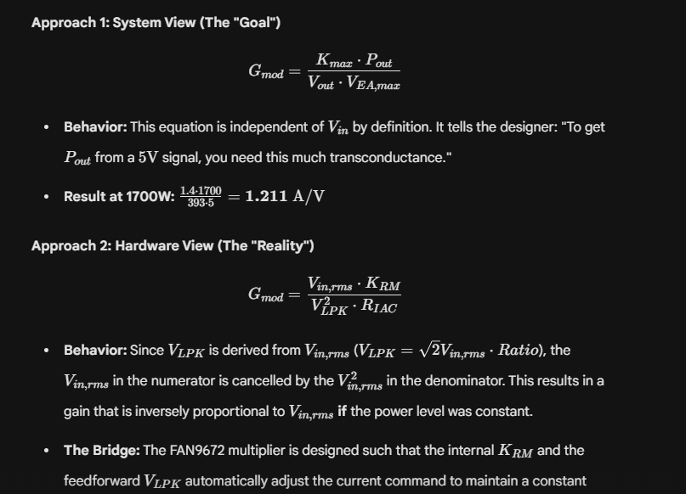

There are two equations for Gmod in above image. Use top equation for loops calculation. For lowline get Gmod from TOP equation and place that value to bottom equation to get Rlpk value.
